4.5" Frameless Ceiling Speaker (3W-6W)
FCS-705N
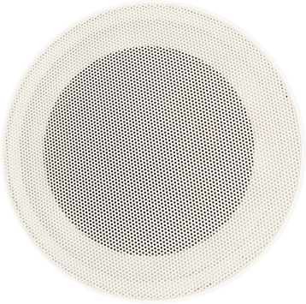
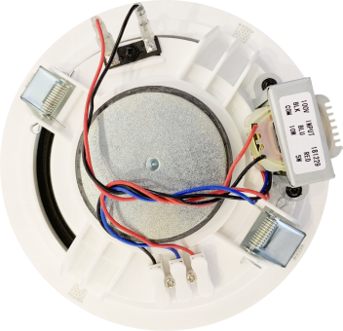
Feature:
- Commercial ceiling speaker with transformer.
- 4.5” ceiling speaker for BGM and PA system use.
- Compact size consistent with spot lighting and architectural design.
- Ideal for school, office, hotel and airport background music system.
- Rated power output 3W-6W at 100V.
- 5" full range paper driver unit.
- Line input 100V or 70V.
- ABS enclosure and metal grille in white.
- In-ceiling quick installation by spring clip.

Specification:
Model | FCS-705N
Description | 4.5” Ceiling Speaker
Rated Power Output | 3W-6W
Line Input | 100V or 70V
Frequency Response | 120Hz-18KHz
SPL(@1W/m) | 92dB ±3db
Speaker Unit | 4.5” full range paper cone
Cutout Size | 148mm
Dimension | 160D)×56(H)mm
Material | ABS enclosure and metal grille in white
Mounting Way | In-ceiling spring clip quick installation
Weight | 0.42kg

Frequency Response VS SPL:
